***Chemistry***

**14: Acid-Base Equilibria**

**14.7: Acid-Base Titrations**

109. Explain how to choose the appropriate acid-base indicator for the titration of a weak base with a strong acid.

Solution

At the equivalence point in the titration of a weak base with a strong acid, the resulting solution is slightly acidic due to the presence of the conjugate acid. Thus, pick an indicator that changes color in the acidic range and brackets the pH at the equivalence point. Methyl orange is a good example.

111. Why can we ignore the contribution of water to the concentrations of  in the solutions of following acids:

0.0092 *M* HClO, a weak acid

0.0810 *M* HCN, a weak acid

0.120 *M * a weak acid, *K*a = 1.6  10–7

But not the contribution of water to the concentration of OH–?

Solution

In an acid solution, the only source of OH– ions is water, while the concentration of H+ is usually significantly affected by the protons of the dissolved acid. We use *K*w to calculate the concentration. If the contribution from water was neglected, the concentration of OH– would be zero.

113. Draw a curve for a series of solutions of HF. Plot  on the vertical axis and the total concentration of HF (the sum of the concentrations of both the ionized and nonionized HF molecules) on the horizontal axis. Let the total concentration of HF vary from 1  10–10 *M* to 1  10–2 *M*.

Solution





The methodology for conducting the calculations is as follows: Because HF is a weak acid, the ionization is not complete; thus the  concentration will always be less than the initial molarity of the HF concentration. Thus for initial concentrations from 10–10 *M* to 1  10–7 *M*, the contribution of  ions to the solution will be smaller than the contribution of  ions from the self-ionization of water. Thus the  concentration in HF solutions of 10–10 to 10–8 *M* is approximately 1  10–7 *M*. Calculate the concentration of  in a 1  10–7 *M* solution of HF. Setting up a table for the changes in concentration, we find:

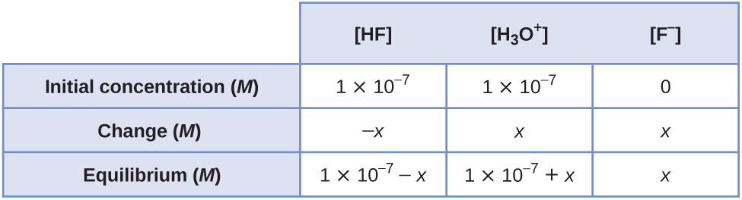

Putting the concentrations into the equilibrium expression gives:



Recognizing that the initial concentration of HF, 1  10–7 *M*, is very small and that *K*a is not extremely small, we would expect that *x* cannot be neglected. Therefore, we will solve for *x* using the quadratic formula:

*x*2 + 3.501  10–4*x* – 3.5  10–11 = 0



As suspected, *x* is of the same order of magnitude as 1.0  10–7; therefore, it was necessary for us to use the quadratic formula. The  concentration in a 1.0  10–7 *M* HF solution is:

 = 1.0  10–7 + *x* = 1.0  10–7 + 0.9995  10–7 = 1.999  10–7 *M*

Let’s calculate the  concentration in 1  10–6 *M* HF solution. Again, because the concentration of HF is so small, we will consider the initial  to be 1  10–7 *M* from the ionization of water. The change in concentrations is:

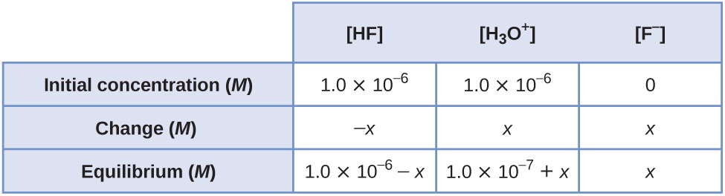

As we found in the last calculation, we would expect that *x* is not small relative to 1  10–6 and 1  10–7. Therefore, we will use the quadratic formula to solve for *x*:



*x*2 + 3.501  10–4*x* – 3.5  10–10 = 0



The  concentration in a 1  10–6 *M* HF solution is:

 = 1.0  10–7 + 9.97  10–7 = 1.10  10–6 *M*

From this calculation we can see that the contribution of  from the self-ionization of water is becoming insignificant relative to the concentration of  generated from the ionization of HF. Thus, for all subsequent concentrations of HF greater than 10–6 *M*, we will not have to consider the ionization of water. To make the plot indicated in this exercise, it is necessary to choose at least two more concentrations between 10–6 *M* and 10–2 *M*. We will do one more calculation of  at an HF concentration of 10–2 *M*. However, this calculation will be done the same way for any concentration greater than 10–6 *M*. The change in concentrations is:

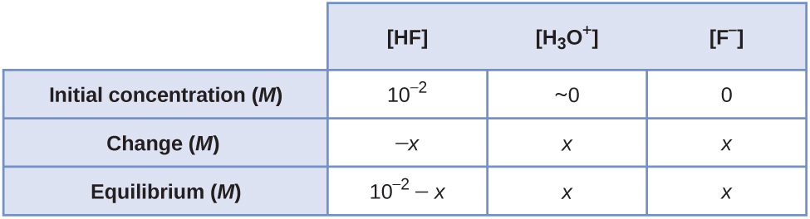

Putting these values in the equilibrium expression gives:



*x*2 + 3.5  10–4*x* – 3.5  10–6 = 0

  
This value of *x* justifies our use of the quadratic formula rather than using the approximation method, for *x*, 1.70  10–3, is 17% of 10–2 *M*.

Calculating the  concentration for a 10–4-*M* solution of HF, we find:

 = *x* = 8.12  10–5 *M*

Plotting the values of  that we have calculated gives the following:

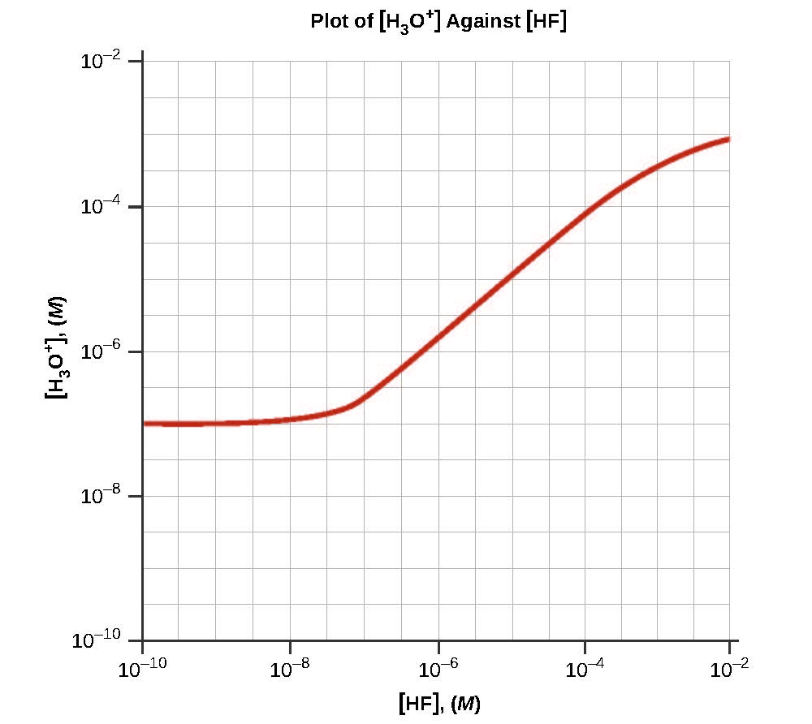

115. Calculate the pH at the following points in a titration of 40 mL (0.040 L) of 0.100 *M* barbituric acid (*K*a = 9.8  10–5) with 0.100 *M* KOH.

(a) no KOH added

(b) 20 mL of KOH solution added

(c) 39 mL of KOH solution added

(d) 40 mL of KOH solution added

(e) 41 mL of KOH solution added

Solution

(a) Let HA represent barbituric acid and A– represent the conjugate base. The reaction and equilibrium constant are:





The initial and equilibrium concentrations for this system can be written as follows:

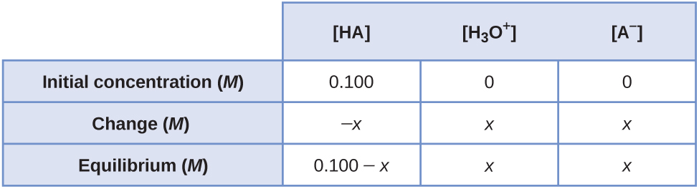

Substituting the equilibrium concentrations into the equilibrium expression, and making the assumption that (0.100 – *x*) ≈ 0.100, gives:



Solving for *x* gives 3.13  10–3*M*. Because this value is less than 5% of 0.100, our assumption is correct. Therefore,  = 3.13 × 10–3 *M*:

pH = –log (3.13  10–3) = 2.504 = 2.50;

(b) The moles of OH– added are given by:

mol OH– = *M*  *V* = (0.100 *M*) × (0.020 L) = 0.00200 mol

The initial moles of barbituric acid are given by:

mol HA = *M*  *V* = (0.100 *M*) × (0.040 L) = 0.00400 mol

Assume that the added hydroxide ion reacts completely with an equal number of moles of HA, forming an equal number of moles of A– in the process. Thus, the moles of the ions are given by:

mol HA = 0.00400 – 0.00200 = 0.00200 mol

mol A– = 0.00200 mol

The total volume is:

40.0 mL + 20.0 mL = 60.0 mL = 0.0600 L

The initial concentrations of the ions are given by:



The initial and equilibrium concentrations for this system can be written as follows:

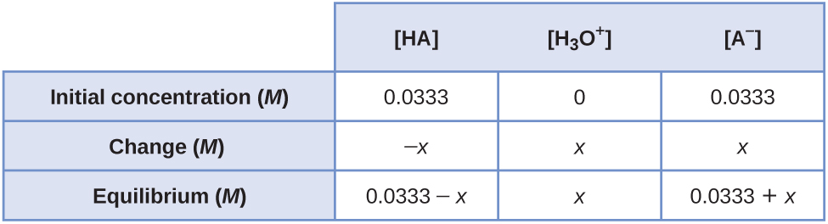

Substituting the equilibrium concentrations into the equilibrium expression, and making the assumptions that (0.0333 – *x*) ≈ 0.0333 and (0.0333 + *x*) ≈ 0.0333, gives:



Solving for *x* gives 9.8  10–5*M*. Because this value is less than 5% of 0.0333, our assumptions are correct. Therefore,  = 9.8  10–5*M*:

pH = –log(9.8  10–5) = 4.009 = 4.01;

(c) The moles of OH– added are given by:

mol OH– = *M*  *V* = (0.100 *M*) × (0.039 L) = 0.00390 mol

The initial moles of barbituric acid are given by:

mol HA = *M*  *V* = (0.100 *M*) × (0.040 L) = 0.00400 mol

Assume that the added hydroxide ion reacts completely with an equal number of moles of HA, forming an equal number of moles of A– in the process. Thus, the moles of the ions are given by:

mol HA = 0.00400 – 0.00390 = 0.00010 mol

mol A– = 0.00930 mol

The total volume is:

40.0 mL + 39.0 mL = 79.0 mL = 0.0790 L

The initial concentrations of the ions are given by:



The initial and equilibrium concentrations for this system can be written as follows:

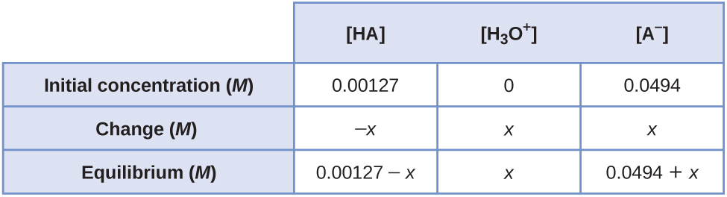

Substituting the equilibrium concentrations into the equilibrium expression, and making the assumption that (0.00127 – *x*) ≈ 0.00127 and (0.0494 + *x*) ≈ 0.0494, gives:



Solving for *x* gives 2.52  10–6 *M*. Because this value is less than 5% of 0.00127 and 0.0494, our assumptions are correct. Therefore,  = 2.52  10–6 *M*:

pH = –log(2.52  10–6) = 5.599 = 5.60;

(d) The moles of OH– added are given by:

mol OH– = *M*  *V* = (0.100 *M*)  (0.040 L) = 0.00400 mol

The initial moles of barbituric acid are given by:

mol HA = *M*  *V* = (0.100 *M*)  (0.040 L) = 0.00400 mol

This is the equivalence point, where the moles of base added equal the moles of acid present initially. At the equivalence point:

mol A– = 0.00400 mol

The total volume is:

40.0 mL + 40.0 mL = 80.0 mL = 0.0800 L

The initial concentration of the conjugate base is:



The reaction and equilibrium constant are:



The initial and equilibrium concentrations for this system can be written as follows:

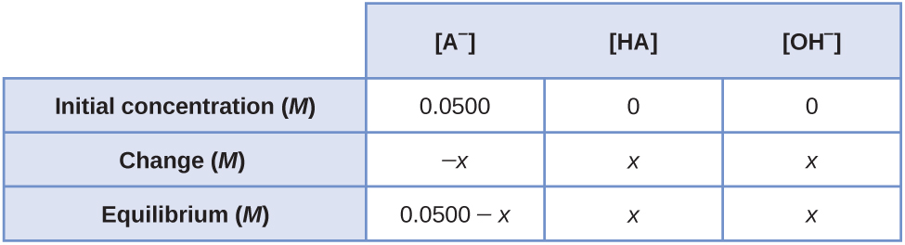

Substituting the equilibrium concentrations into the equilibrium expression, and making the assumption that (0.0500 – *x*) ≈ 0.0500, gives:



Solving for *x* gives 2.26  10–6 *M*. Because this value is less than 5% of 0.0500, our assumption is correct. Therefore, [OH–] = 2.26  10–6 *M*:

pOH = –log(2.26  10–6) = 5.646

pH = 14.000 – pOH = 14.000 – 5.646 = 8.354 = 8.35;

(e) The moles of OH– added are given by:

mol OH– = *M*  *V* = (0.100 *M*) × (0.041 L) = 0.00410 mol

The initial moles of barbituric acid are given by:

mol HA = *M*  *V* = (0.100 *M*) × (0.040 L) = 0.00400 mol

This is past the equivalence point, where the moles of base added exceed the moles of acid present initially. The excess moles of hydroxide ion are given by:

mol OH– = 0.00410 – 0.00400 = 0.00010 mol

The total volume is:

40.0 mL + 41.0 mL = 81.0 mL = 0.0810 L

The concentration of OH– is:



pOH = –log(0.0012) = 2.921

pH = 14.000 – pOH = 14.000 – 2.921 = 11.079 = 11.08

This resource file is copyright 2015, Rice University. All Rights Reserved.